Course Project – Output

Shaun Pritchard

Rasmussen College

QMB3200

Kimberly Powell

July,30 2020

**Course Project – Weekly Sales**

For this project I used SAS to calculate mean sales over the holiday per store/department for each month. I calculated the standard deviation, mean, Max, Min, Range and used ODS to generate graphical output data including printing a PDF files report Mod4_Stats.

**Code:**

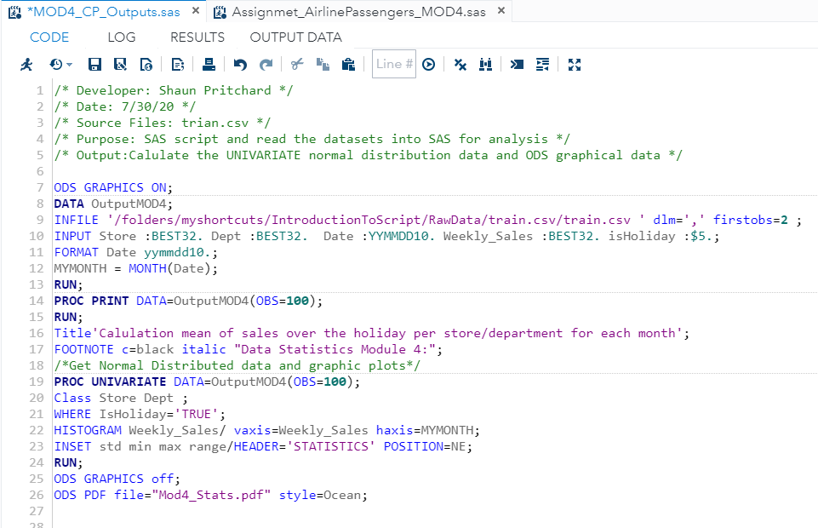

Output:

